Auto Robotics – final project:

ID: 207047986

Name: Shahak Nir

I chose to focus on the value that auto drones, and data science could influence the agronomic world.

My father owns 400 acres of vineyard of many different kinds, therefore he is required to eases each plot differently – hance each kind has it's weakness and strengths.

In the following paper I'll lay down all my affects and what I've learned during working on this project.

**In general:**

This specific plot is 8 years old – started to give crop 4 years ago.

It's located in the middle of a valley therefore the clement is a little different, so we need as much monitoring this plot.

Using anatomic drone to extract data from the vineyard and analyzing it by a software. That's the future of agriculture and as sone as we get onboard we'll benefit from it.

**Logistics – drone:**

We chose a plot to examine and a small drone to get data within the plot's rows using 360O camera hanging from it.

Since the camera change the center of the weight of the phantom3 drone – I've decided to try using a different drone – Mavric2, a smaller drone that will be able to manipulate in the curves and manage with the breeze from the valley.

We went on 3 different shooting days and after crushing the drone a few times – I got an out-sourced pilot (my cousin).

**Field work:**

We went to our plot 3 different days to get the best data to work with.

And after the third day we extracted 4 strong and swamped with data from the plot, I've started validating the data.

Analyzing it using Open Drone Map, I found that I can use the points cloud and run a software to analyze it's RGB values everyday and compare them using the points cloud we extracted as a graph with nodes of green shades.

**The result:**

The plot I examined showed that there are some difficulties at the edge of the plot:

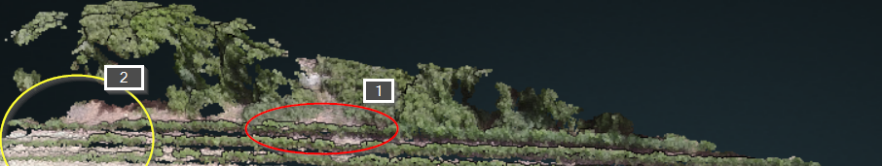

In the first circle (red circle) we can see a bit smaller growth that may be caused by the wild bushes in the edges of the plot.

In the second circle (yellow circle) it may look like a slow growth of the planets in that area, but that’s only because the drone fly above it directly.

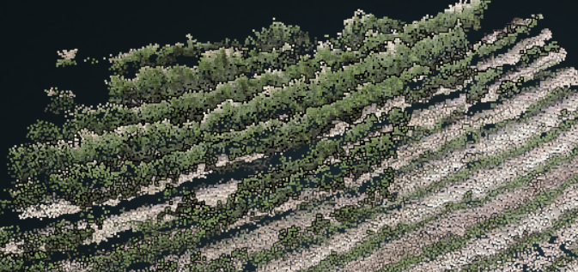

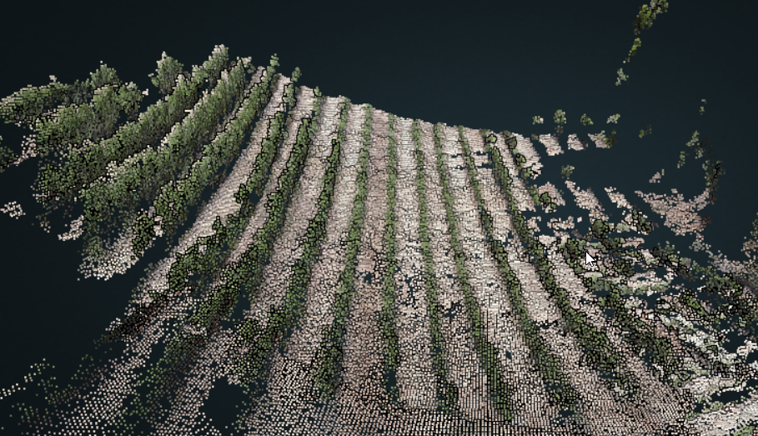

In the could point models above and under we can see that we can analyze each point – as a node – in a graph and evaluate it's RGB values and compare it with the plot's average values.

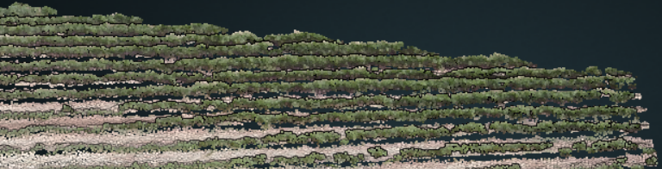

Our plot suffered from lack of water in the first hot days and so we can see in the following 3D model the yellow areas:

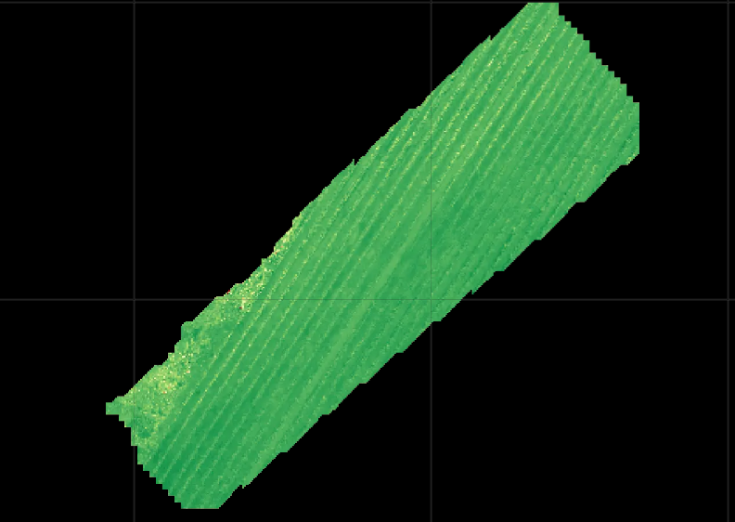

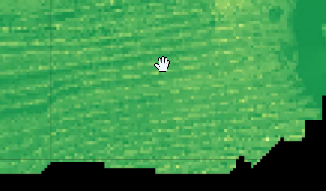

I found that planning the mission takes more time then actually flying in the field.

Although 360O camera would've get us more accurate data, the goal is that the drone will be fully anatomic – take off in the warehouse and return once he has finished his job/ his battery is low etc.…

All along the project I've learned how to use a drone – and of course how make it anatomic.

I found a lot of data and past researchers from the field of agriculture in general but less for vineyards.

**Conclusion:**

The future of efficient agriculture is here. By using the cloud point we can produced and find the new hazards in our vineyard or any corp.

We can simply monitor our plants progress now.

**Flight logs and mission plan:**

